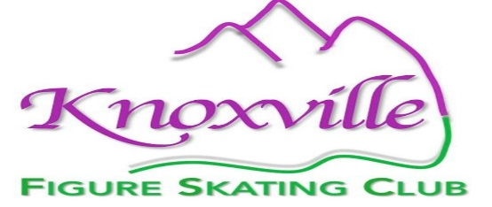
The Knoxville Figure Skating Club, a registered 501c3 non-profit organization and official U.S. Figure Skating Club, is seeking dedicated, eligible members for its Board of Directors.
Interested in running for the board?
Please, return the following interest form no later than October 30th to the KFSC Nominating Committee at: knoxskating@gmail.com
Thank you so much for your interest!
Robert Darby
Vanessa Caja
Abby Pace
KFSC Nominating Committee

Please Note: You must be a member in good standing and meet the requirements listed in the KFSCE Bylaws (https://knoxvillefigureskatingclub.org/wp-content/uploads/2022/05/KFSC-Bylaws-2022.pdf ) to be eligible for the Board of Directors. Upon receipt of this form the KFSC Nominating Committee will contact you with additional instructions.
- Name:

- How many years have you been a KFSC member?

- How would KFSC benefit from your involvement with the board?

- What ways have you contributed to KFSC during your membership?

Please be aware that the KFSC Board of Directors is volunteer and requires a significant commitment of time both in and outside of the skating rink.
Expectations of Board Members
• Attend regularly scheduled board meetings
• Participate in committee work
• Become informed about the policies and programs of the club
• Participate in fundraising activities and special events sponsored by the club
• Participate in board orientation activities
• Act as an informed advocate of the club
• Be Safe Sport Certified (USFS requirement)
• Submit to a background check (USFS requirement)
A list of candidates will be distributed on November 1st for the December 1st Board Election.
Return completed application to the Nominating Committee: mailto:knoxskating@gmail.com

